Adelphi Metals Inc. Options The Brady Sudbury Project
Vancouver, BC – March 3rd, 2026 – Adelphi Metals Inc. (CSE: ADP) (“Adelphi” or the “Company”) is pleased to announce it has signed an option agreement with an arm’s length vendor to acquire the Brady Sudbury Project, which includes the Parkin (Golden Pine, Marble Mountain, Black Creek and Terra Incognita), Fraleck, and River North claim groups covering a total area of 8,811 ha. The properties have the potential to host mesothermal lode gold, IOCG mineralization, nickel copper, and placer/till hosted gold mineralization. Located on the northeast corner of the Sudbury Structure, the Parkin property is about 40 km north of Sudbury with the Fraleck and River North properties situated an additional 6 km to the north.
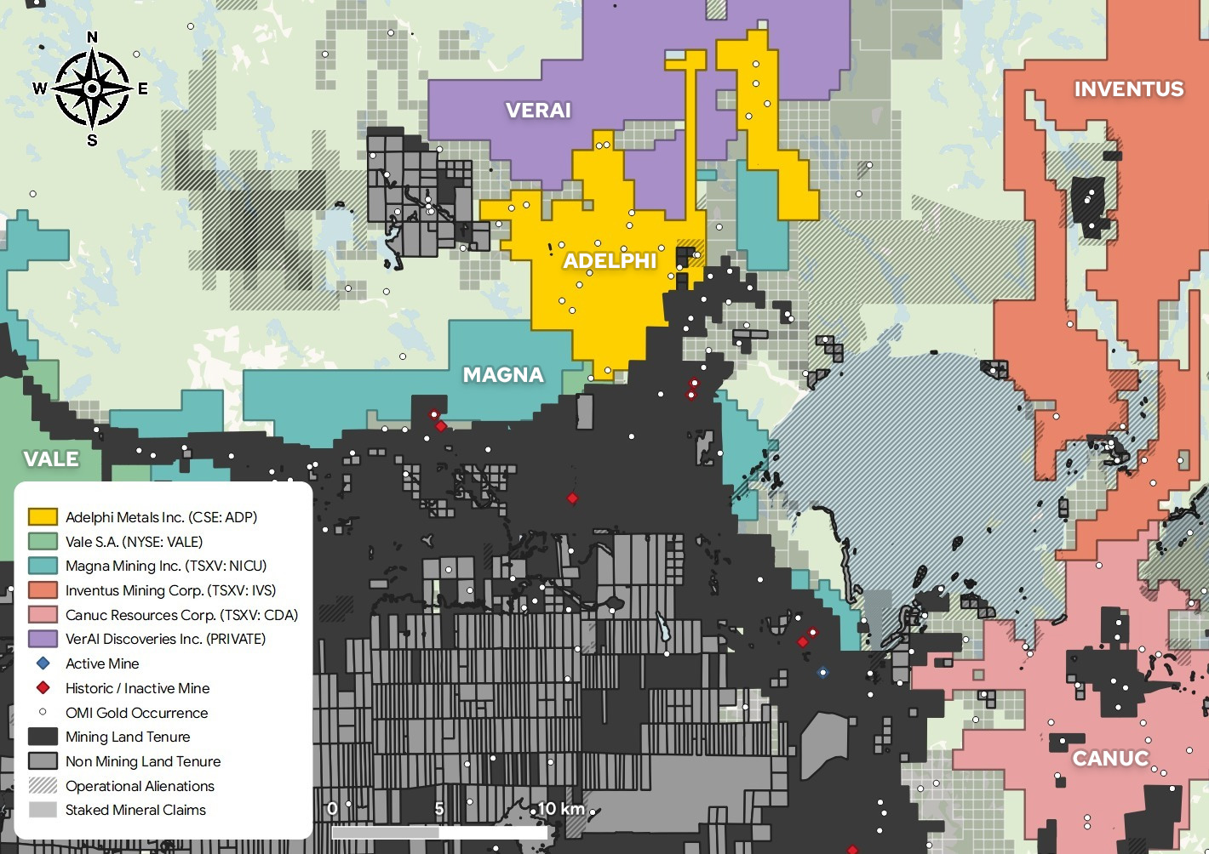
Figure 1. Location map of the newly optioned Brady Sudbury Project
There are a number of lode gold showings hosted by volcanic rocks of the Archean Benny greenstone belt exposed in the central portion of the Parkin claim group with the most significant mineralization being in the Golden Pine area. Quartz-carbonate stringer veins within an approximately 150 m wide, northeast-trending shear/fracture system cutting altered felsic volcanic rocks hosts up to 40% disseminated pyrite with occasional malachite and azurite. Historical exploration has identified four subparallel zones, the A, A1, B and C, with sampling results including 29.8 g/t Au and 55 g/t Ag over 0.69 m in a drill hole in the “A” Zone¹; 6.89 g Au/t over 1.37 m in hole 96-9 from the “A-1” Zone¹; and 14.62 g Au/t and 34.29 g Ag/t over 0.76 m in a channel sample from the “B” Zone¹. A 2021 review² of the historical geophysical data highlighted an approximately 1 km long northeast-trending chargeability anomaly associated with the shear system which has not been drill tested.
The Galena / Pyrite Hill and Calcite gold showings, located to the north of the Golden Pine area, are hosted in Huronian sediments cut by northwest-trending structures that regionally extend south along the east side of the Sudbury Structure into the area of the IOCG style gold mineralization at the Scadding Gold Mine. Trenching in 2021 at Galena/Pyrite Hill exposed quartz-carbonate veins with associated pyrite, galena, with minor chalcopyrite. Channel sample results included 3.2 g/t Au, 0.34 g/t Ag, and 0.36 ppm Te over 5.98 m in Channel 5². Two of three 2021 drill holes intersected gold mineralization including 21.19 g/t Au and 1.4 g/t Ag over 0.68 m in SM-21-03². Post drilling review of the geophysical data indicated that the holes were not optimally located, and additional drilling was recommended but not completed. At the Calcite Showing, located approximately 1.5 km northwest of Galena/Pyrite Hill, up to 4.25 m of disseminated to massive pyrite in siliceous/cherty intervals was intersected in historical diamond drilling returned 1.54 g/t Au over 1 m and 0.583 g/t Au over 1.16 m³. Selected samples were reportedly re-sampled and returned 3.1 g/t Au and 20.57 g/t Au along with 0.85% Cu, 0.66% Ni, 3% Zn and 0.07% Co⁴. A southwest-trending chargeability anomaly associated with the Calcite Showing appears to intersect the northeast-trending Golden Pine anomaly in an area with no recorded historical diamond drilling².
IOCG mineralization may also be present on the River North property, located about 6 km to the north of the Parkin claims. River North is situated along the major regional north-trending Wanapitei Fault which projects south into the area of the IOCG gold mineralized Scadding Mine south of Lake Wanapitei. Sulphide mineralization is found associated with shears in Huronian sediments and Nipissing-type gabbro. River North contains the Inco Gold, Brady Gold, Wanapitei River Copper, and Fraleck/Towers showings which host gold-copper mineralization. Quartz veining in carbonate altered gabbro at the Inco Gold showing has returned 0.18 to 0.67% Cu, and 7.8 to 173 ppb Au⁵ but up to 2.00% Cu and 8.7 g/t Ag, and 3.99 g/t Au from two historical grab samples⁶. The vein on the Fraleck/Tower Showing contains galena, cerussite (PbCO3), anglesite (PbSO4), chalcopyrite, pyrite, arsenopyrite, covellite and native gold, and a historical grab sample returned 12.93% Pb, 1.50 %Cu, 1.49 oz/ton Ag, and 0.91 oz/ton Au⁷. The Parkin Offset dyke of the Sudbury Structure has been traced to within a short distance of the western edge of the property. Smaller offset dykes have also been identified on the south side of the Parkin property by OGS mapping.
There are five sites of gold mineralization in till along the Vermillion River defined by historical reverse circulation drilling and sampling over an area that suggests the potential for placer gold mineralization. A 2015 overburden hole program managed by Overburden Drilling Management returned nine samples exceeding 10-grain anomalies with a sample from hole 20 yielding 225 grains or a calculated Au value of 6,658 ppb⁸. Approximately 2 km to the north, a 2011 diamond drill hole BC-11-002 intersected 2.27 g/t Au over 1.0 m within a zone that averaged 1.0 g/t Au over 8.9 m⁹. The Vermilion River follows the major northwest-trending Milnet Fault, and in part bounds the western side of the Benny Greenstone Belt.
To earn a 100% interest in the project Adelphi will make cumulative payments over a 3-year period, including $710,000 cash and 1,450,000 common shares. Over the same time period, Adelphi will incur expenditures of $1,050,000. An NSR of 2.5% will be granted to the vendor of which the Company can purchase back 1% at anytime for $1.5 million.
The Company further announces that it has arranged a non-brokered private placement of 5 million units ("Units") at a price of $0.10 per Unit for aggregate gross proceeds of $500,000 (the "Offering"). Each Unit will be comprised of one common share ("Share") and one half transferable Share purchase warrant of the Company ("Warrant"). Each whole Warrant will entitle the Subscriber to purchase one Warrant Share for a 24-month period after the Closing Date at an exercise price of $0.15 per share. Net proceeds of the Financing will be used to advance the Corporation's mineral assets, potential acquisitions, and for general working capital purposes.
Shares issued pursuant to the Financing and under the option agreement will be subject to a four-month hold period according to applicable securities laws of Canada.
Finders' fees may be payable on the private placement, subject to the policies of the Canadian Securities Exchange.
Qualified Person
The technical elements of this press release have been approved by Mr. Thomas Hart, P.Geo. (PGO), a Qualified Person (QP) and Independent Consultant under National Instrument 43-101. The QP has visited the Parkin claim group but has not yet visited the River North or Fraleck groups.
About Adelphi Metals
Adelphi Metals Inc. is engaged in the business of mineral exploration and the acquisition of mineral property assets in Canada. Its objective is to locate and develop economic precious and base metal properties of merit and to conduct its exploration program on the Triple R property.
ON BEHALF OF THE BOARD
“Mike England”
Mike England, CEO & Director
FOR FURTHER INFORMATION PLEASE CONTACT:
Telephone: 1-604-683-3995
Email: info@adelphimetals.com
Neither the Canadian Securities Exchange nor its Regulation Services Provider accepts responsibility for the adequacy or accuracy of this release.
This news release includes certain “forward-looking statements” within the meaning of applicable Canadian securities legislation. Forward-looking statements relate to future events or performance and reflect management’s expectations at the time of this release. Such statements include, but are not limited to, anticipated exploration programs, results of exploration activities, the ability to obtain necessary permits and approvals, the availability of financing, and future business plans. Forward-looking statements are often identified by words such as “expects,” “plans,” “anticipates,” “believes,” “intends,” “estimates,” “may,” “could,” “would,” “might,” or “will.”
These statements are based on a number of assumptions, including the availability of financing on reasonable terms, the receipt of necessary regulatory approvals, and sustained demand for precious and base metals. Forward-looking statements are subject to known and unknown risks and uncertainties that may cause actual results to differ materially from those expressed or implied, including risks related to exploration, development, financing, permitting, changes in laws and regulations, operating history, title, environmental matters, pandemics, and other risks disclosed in the Company’s filings with Canadian securities regulators, available at www.sedarplus.ca.
Readers are cautioned not to place undue reliance on forward-looking statements. The Company undertakes no obligation to update or revise any forward-looking statements except as required by law.
References
1: Ontario Ministry Of Energy and Mines assessment report 41I15SW0039
2: Ontario Ministry Of Energy and Mines assessment report 20000019503
3: Ontario Ministry Of Energy and Mines assessment report 41I15SW0034
4: Ontario Ministry Of Energy and Mines assessment report 20000008949
5: Ontario Ministry Of Energy and Mines assessment report 41I15NW2001
6: Ontario Ministry Of Energy and Mines assessment report 20000022583
7: Ontario Ministry Of Energy and Mines mineral deposit inventory record MDI41I15NW00015
8: Ontario Ministry Of Energy and Mines assessment report 2.56392
9: Ontario Ministry Of Energy and Mines assessment report 20000007752

